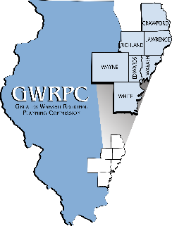

Agenda for the
Greater Wabash Regional Planning Commission
Board of Directors

Thursday, February 24, 2022
6:00 pm
GWRPC, Albion, IL

- Call to Order Joe Judge, Chairperson
Pledge of Allegiance

Presentation of the Audit by Special Guest James Murphy, Leymone Hardcastle & Co. CPA

- Committee Reports
Amended 2021-2022 Budget Randy Hallam, Treasurer

- Discussion Topics
Appointment of Nomination Committee Joe Judge, Chairman

- Adjourn

Next meeting March 24, 2022- 5:30 p.m.- The Barn at New Leaf, Lawrenceville, IL

Agenda for the
Greater Wabash Regional Planning Commission
Personnel Committee

Thursday, February 24, 2022
4:30 pm
GWRPC, Albion, IL

- Call to Order

- 2021 Staff Evaluations

- Adjourn

Agenda for the
Greater Wabash Regional Planning Commission
Finance Committee

Thursday, February 24, 2022
5:30 pm
GWRPC, Albion, IL

- Call to Order

- 2021-2022 Amended Budget

3. 2022-2023 Budget

- Adjourn

