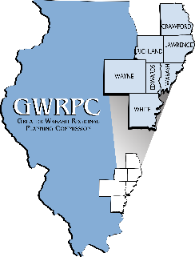

Agenda for the
Greater Wabash Regional Planning Commission
Board of Directors

Thursday, March 24, 2022
5:30 pm
The Barn at New Leaf (CoCo’s) Lawrenceville, IL

- Call to Order Joe Judge, Chairperson
Welcome and Introductions

Pledge of Allegiance

GUEST SPEAKER Kala Lambert, DCEO

- Approval of December, February Scott Merkle, Secretary
Minutes

- Approval of December- February Randy Hallam, Treasurer
Financial Report

- Committee Reports
Finance Committee Randy Hallam
2021-2022 Amended Budget
2022-2023 Budget
2022-2023 County Dues

Nominating Committee Charlotte St. Ledger
Election of Officers

- Old Business Joe Judge, Chairperson

- New Business Joe Judge, Chairperson

- Executive Director’s Report Lora Smith, Executive Director
Recognition of Officers

- Adjourn

Next meeting June 23, 2022- 6:00 p.m. - Albion, IL

